**LAYOUT**

Layout: Layout is process in which parts of something are arranged or laid out.

**OR**

The process of setting out material on a page.

**APPLIED THERMODYNAMICS LAB** 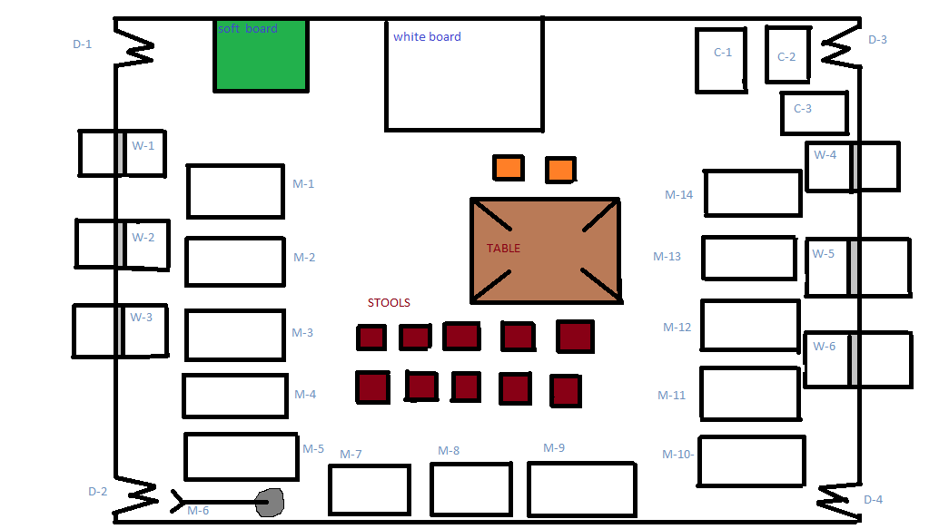

**EXPLANATION OF LAY OUT:**

**D-1:**

Door # 1

**D-2:**

Door # 2

**D-3:**

Door # 3

**D-4:**

Door # 4

**W-1:**

Window # 1

**W-2:**

Window # 2

**W-3:**

Window # 3

**W-4:**

Window # 4

**W-5:**

Window # 5

**W-6:**

Window # 6

**C-1:**

Cup Board # 1

**C-2:**

Cup Board # 2

**C-3:**

Cup Board # 3

**M-1: (1.1) Figure # 1-1:**

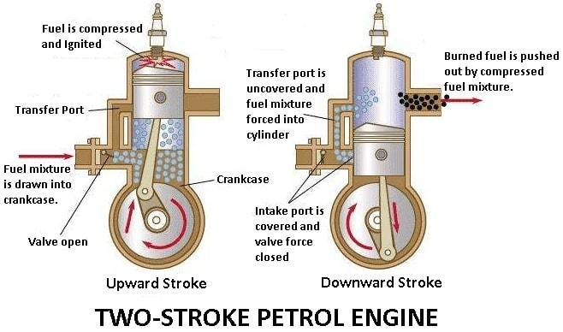Two Stroke Petrol Engine Demonstration Unit A two stroke engine is an internal combustion engine which completes a power with two strokes of the piston during only one crankshaft revolution as shown in figure # 1-1:

**MODEL:**

ART-WR-4042

**M-1: (1.2 )**Four Stroke Single Cylinder Engine A four stroke (also four cycle) is an internal combustion in which the piston completes four separate cycles while turning the crankshaft as shown in figure 1-2: **Figure # 1-2:**

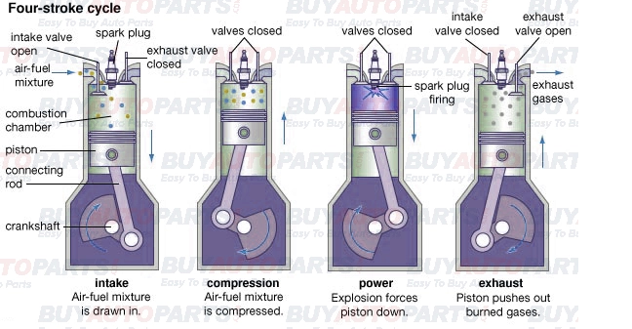

**MODEL:**

IPC-9200-DE

**M-2:**

Rankine Cycle Steam Turbine The Rankin cycle is a model used to predict the performance of steam turbine system. The Rankin cycle is an idealized thermodynamic cycle of a heat engine that converts heat into mechanical work while undergoing phase change as

Shown in **figure # 1-3:**

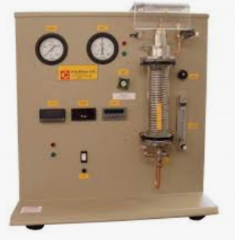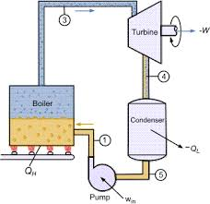kkhhhhh

**Figure # 1-3:**

**MODEL:**

S220 **OR** 03764

**M-3: (3) Figure # 1-4:**

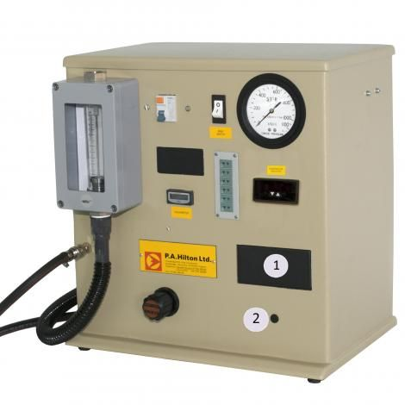Compressible Flow Range Compressible flow (or gas dynamics) is the branch of fluid dynamics that deals with flows having significant changes in fluid density .The study of compressible flow is relevant to high speed air craft’s jet engines as shown in figure # 1-4:

**MODEL:**

F300

**M-3: (3.1)**

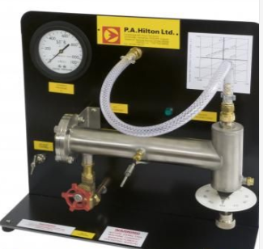Nozzle Performance A series performance of convergent and convergent-divergent nozzle may be installed in one of two **Figure # 1-5:**

Locations in a high pressure measuring chamber as shown in figure # 1-5.

**MODEL:**

F-300A

**M-3: (3.2)** Nozzle Pressure Distribution The nozzle pressure unit allows to investigate the pressure distribution and the mass flow rate in nozzles as shown in figure # 1-6.

**Figure # 1-6:**

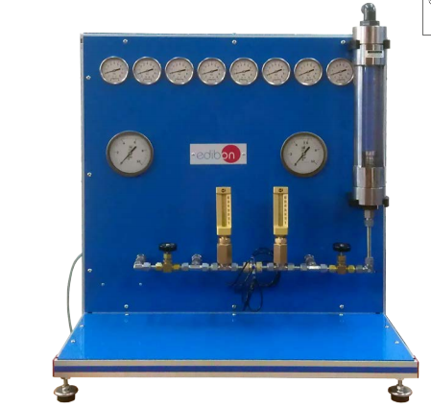

**MODEL:**

F-300B

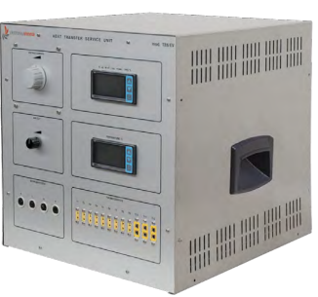**M-4: Figure # 1-7:**

Radiation Heat Transfer Unit Radiation heat transfer is the process in which the thermal energy is exchanged b/w two surfaces by obeying the laws of

Electromagnetic as shown in figure # 1-7.

**MODEL:**

H-112

**M-5:**

Boiling Heat Transfer Module The Formation Of steam **Figure # 1-8:**

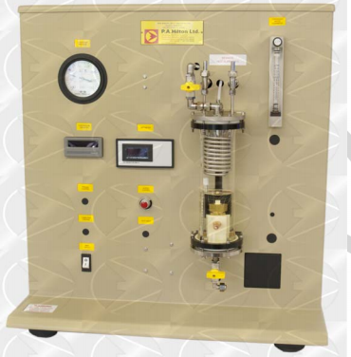 bubbles along a heat transfer surface has a significant effect on the overall heat transfer rate as shown in figure # 1-8.

**MODEL:**

H-1125

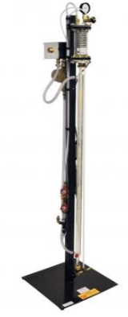**M-6: Figure # 1-9:**

Flow Boiling Demonstration It has been used to provide

Students with a clear visual of demonstration of what is happening

Inside the vapor generating tubes as shown in figure # 1-9.

**MODEL:**

H-411

**M-7: Figure # 1-10:**

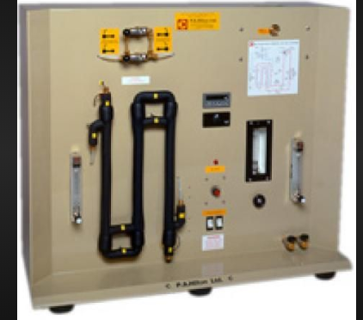 Concentric Tube Heat Exchanger The thermodynamics behavior of concentric heat exchanger can be described by

numerical analysis as shown in figure # 1-10.

**MODEL:**

TD-360A

**M-8: (8.1) Figure # 1-11:**

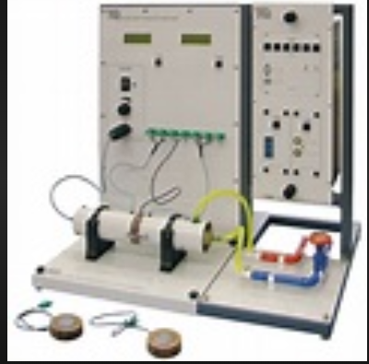Linear Heat Conduction Experienced This experiment has a solid brass disc with an electric heater (heat source)at its centre and a circular cross section cooling tube (heat sink) around its circumference. It mounts on a base plate with a clear schematic of the experiment layout as shown in figure # 1-11.

**MODEL:**

TD-1002A

**M-8: (8.2)**

Absorption Refrigeration It is a refrigerator that uses heat sources (e.g. solar energy) to provide the energy that needed to derive the cooling process as shown in figure # 1-12.

**Figure # 1-12:**

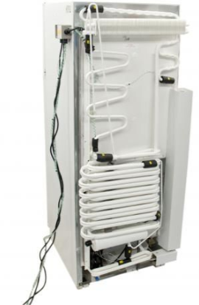

**Model**:

816 **OR** 01295

**M-9: Figure # 1-13:**

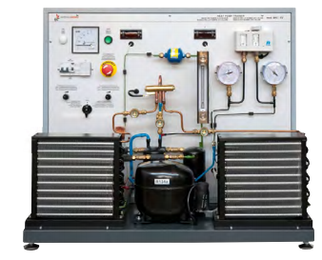Heat Pump Trainer The purpose of a heat pump is to supply heat to a region by taking heat from a lower temperature region

As shown in figure # 1-13.

**MODEL:**

BPC **OR** EV

**M-10:**

Thermo Electric Heat Pump Trainer The Hilton thermo heat pump trainer has been designed to enable students to investigate the performance of a semi conductor **Figure # 1-14:**

**Figure # 1-14:**

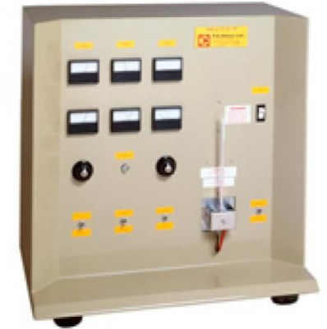

Module which on the application of an electrical power supply, will produce a refrigerating effect.

**MODEL:**

R-534

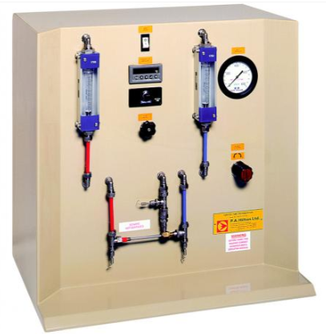**M-10: (10.1) Figure # 1-15:**

Vertex Tube Refrigerator The vortex tube is an interesting tube

in which a compressed gas is divided into two streams at a low pressure. It is an unusual process for producing cooling air as shown in figure # 1-15.

**MODEL:**

R-434

**M-11:**

Commercial Refrigeration Trainer The comprehensive **Figure # 1-16:**

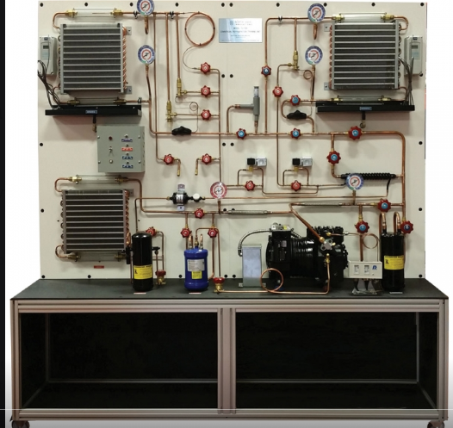 Refrigerator trainer is designed for comprehensive and advanced

Work studies involving industrial and commercial refrigeration

System as shown in figure # 1-16.

**MODEL:**

IPC-2007-1

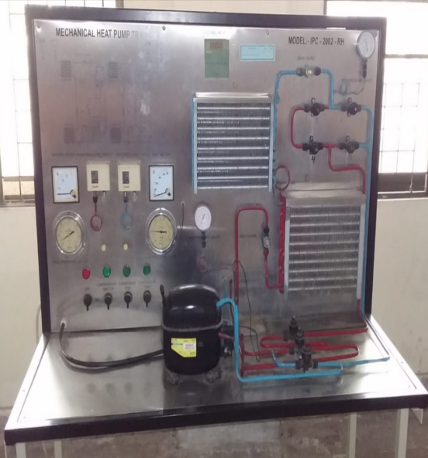**M-12: Figure 1-17:**

Mechanical Heat Pump, Trainer A heat pump is a machine whose prime function is to absorb heat

from a low grade source and to deliver heat at a useful

temperature as shown in figure # 1-17.

**MODEL:**

IPC-2002-RH

**M-13: Figure # 1-18:**

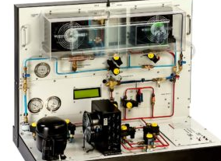Laboratory Air Conditioning Trainer A complete

instrumented air conditioning unit mounted on a steel framed caster wheels as shown in figure # 1-18.

**MODEL:**

IPC-512-RAC

**M-14:**

Cooling Tower Trainer In wet cooling towers **the Figure # 1-19:**

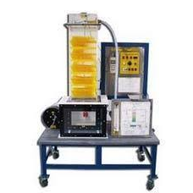 water is to be cooled is sprayed over a wet deck surface, Water and air come into direct contact in counter flour as shown in figure # 1-19.

**MODEL:**

RAD-CTS-3

“THANK YOU TEACHER FOR HELPING ME BLOOM”